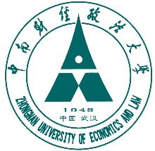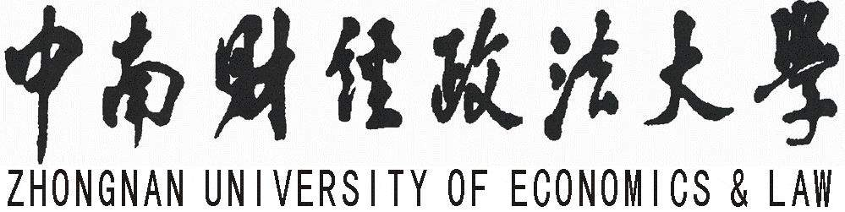

（此处请插入学位证书横版、清晰扫描图片，尺寸为长15厘米、宽11厘米）

CERTIFICATE FOR THE MASTER'S DEGREE

Certificate No: 请填写学位证书编号

This is to certify that Ma Yun(姓名与中文件保持一致), male（性别与中文件保持一致）, born on September 21,1994, （生日与中文件保持一致）, majoring in Master of Finance（专业与中文件保持一致）, has passed the examinations and defence of the thesis for Master Degree in this university with satisfactory results, and satisfied with the Regulations of Academic Degrees in the People's Republic of China, he(人称请据实替换) is thereby granted the Degree of Master of Finance. (学位名称与中文件保持一致).

Zhongnan University of Economics and Law
President: Yang Canming
Chairman of the Degree Senate: Yang Canming
June 20, 2019（颁证日期与中文件保持一致）

地址:湖北省武汉市东湖新技术开发区南湖大道182号文溯楼 邮编:430073 电话（传真）: 027-88387701
ADD: 182# Nanhu Avenue, East Lake High-tech Development Zone, Wuhan 430073, P.R.China TEL (FAX):+86-27-88387701

